Task 3

Create max-temp.txt and copy to HDFS /user/acadgild/hadoop

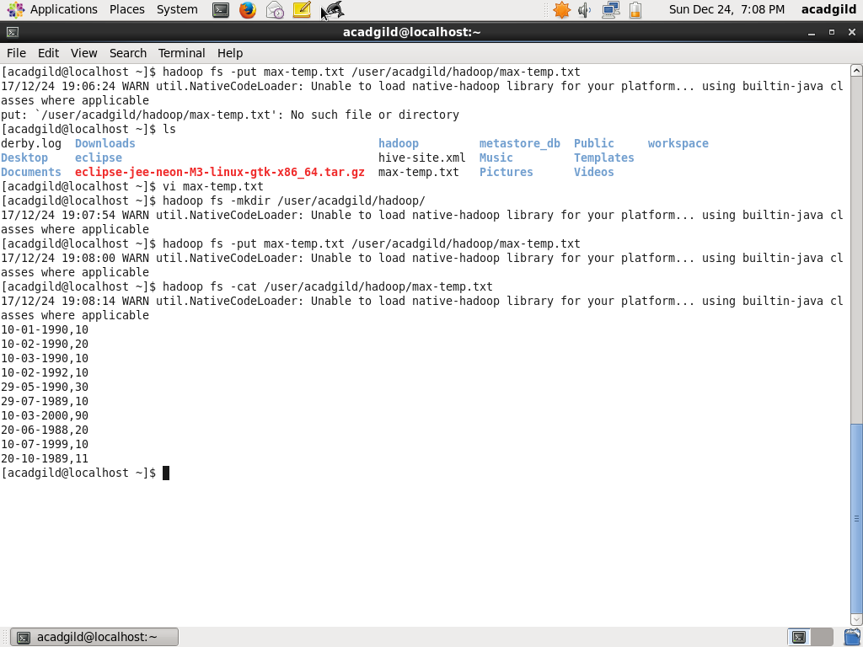

Task 4 : Change permissions such that owner and group have full control

